Ridgemount Cottage Nursery
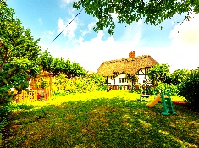 |  | DATE:  REF:  Dear whom it may concern,  Thank you for sending the reference request for the above named. It is our company policy to provide only a factual reference. I have detailed the information below:  Position in the nursery:  Start date with the company:  Left company:  History of disciplinary:  Willing to re-employ:  Safety concerns:  Yours sincerely  Stewart Hendry  Stewart Hendry  Nursery Owner

73 Ermin st,
Brockworth,
Gloucester
GL3 4EH
01452 864107
office@ ridgemountnursery.com
Exploration
Discovery
Independence
Community

