103. Accident Form
Our accident forms are recorded on Tapestry.
Go to:
Care Diaries
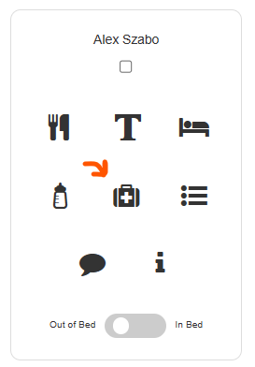
Click on the Child’s in question on the accident icon
CHILD’s NAME

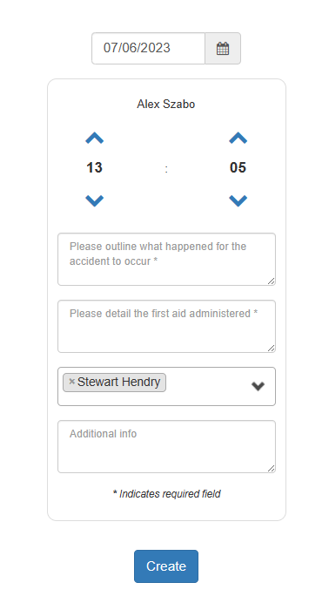

CHILD’s NAME

This will bring up an accident Form

